Two Nucleoporin 98 homologous genes jointly participate in the regulation of starch degradation and enhance growth in Arabidopsis
Long Xiao^{1, §}, Shanshan Jiang^{2, §}, Penghui Huang^{2, §}, Fulu Chen², Xu Wang², Zhiyuan Cheng², Yuchen Miao³, Liangyu Liu⁴, Iain Searle⁵, Chunyan Liu¹, Xiaoxia Wu¹, Yong-Fu Fu^{2, *, ¶}, Qingshan Chen^{1, *}, Xiao-Mei Zhang^{2, *}

Supplementary Figures
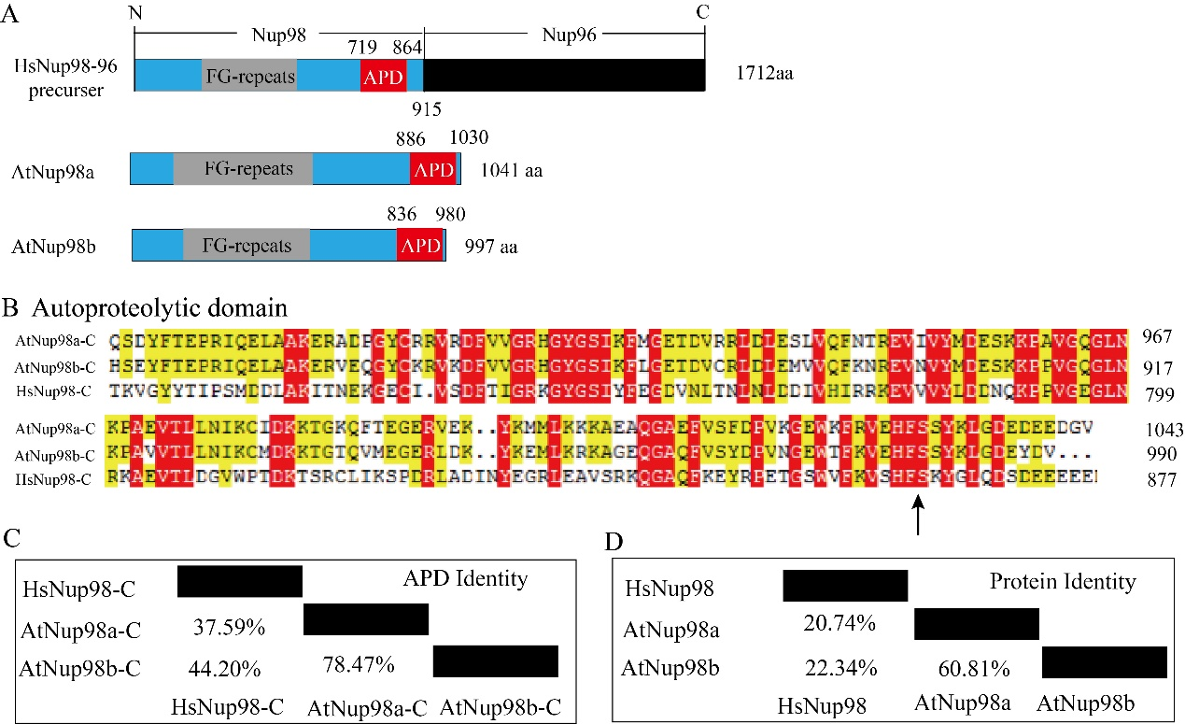

Figure S1. Protein domains in Nup98a and Nup98b of Arabidopsis thaliana. A, Sketches of Nup98-96 proteins from Homo sapiens HsNup98-96 (NM_016320.4) and two homologs from Arabidopsis thaliana Nup98a (At1g10390) and Nup98b (At1g59660). APD, autoproteolytic domains. FG, phenylalanine and glycine repeats. B, Alignment of the autoproteolytic domains of HsNup98-96, At Nup98a and At Nup98b. The arrow indicates the conserved HFS cleavage site. C, Overall identity of the autoproteolytic domains of HsNup98-96, At Nup98a and At Nup98b. D, Overall identity of the proteins of HsNup98-96, At Nup98a and At Nup98b.

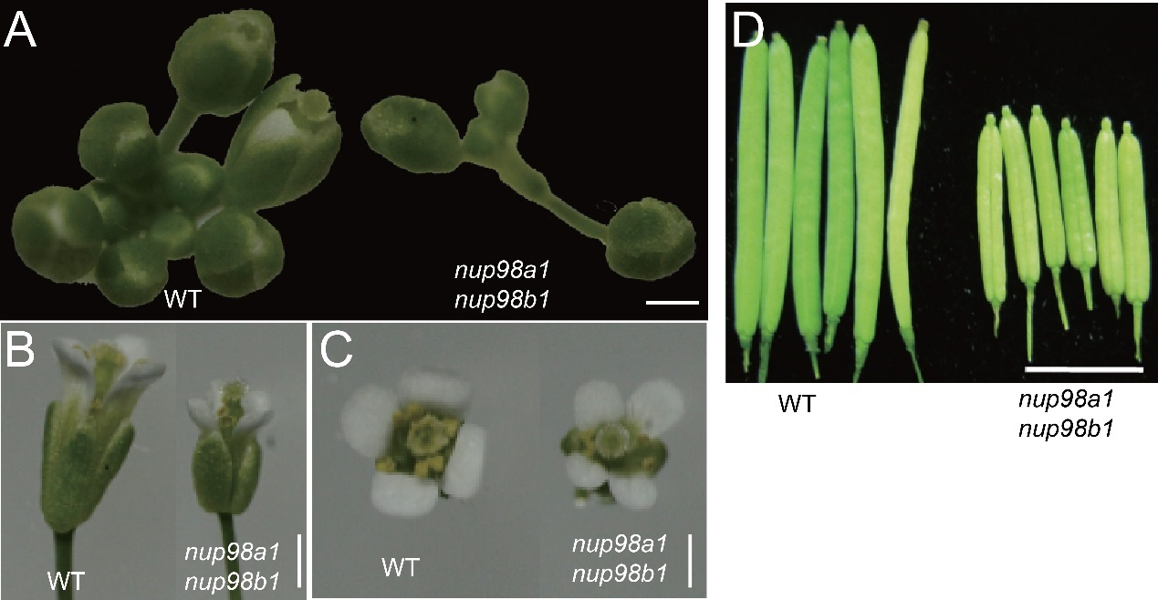
Figure S2. The nup98a1 nup98b1 double mutant showed pleiotropic defeat in various organs. The seeds of mutant and WT were sown in soil after low temperature treatment for 3 days on wet filter paper and grew in long day conditions. A, A top view of Inflorescence; B, A side view of flowers; C, A top view of flowers; D, Siliques. Scale bars = 2 mm.

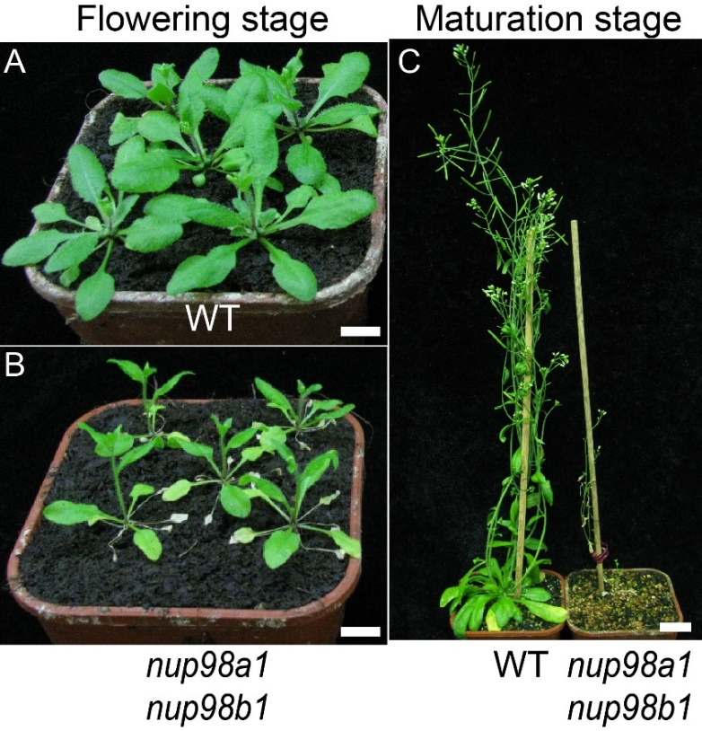
Figure S3. The nup98a1 nup98b1 double mutant showed senescence and sterility phenotype. The seeds of mutant and WT were sown in soil after low temperature treatment for 3 days on wet filter paper and grew in long day conditions. A and B, Plants at early stage of flowering. Plants grew in dishes supplemented with MS and sucrose for one week, and then transplanted in soil. C, Plants at mature stage.

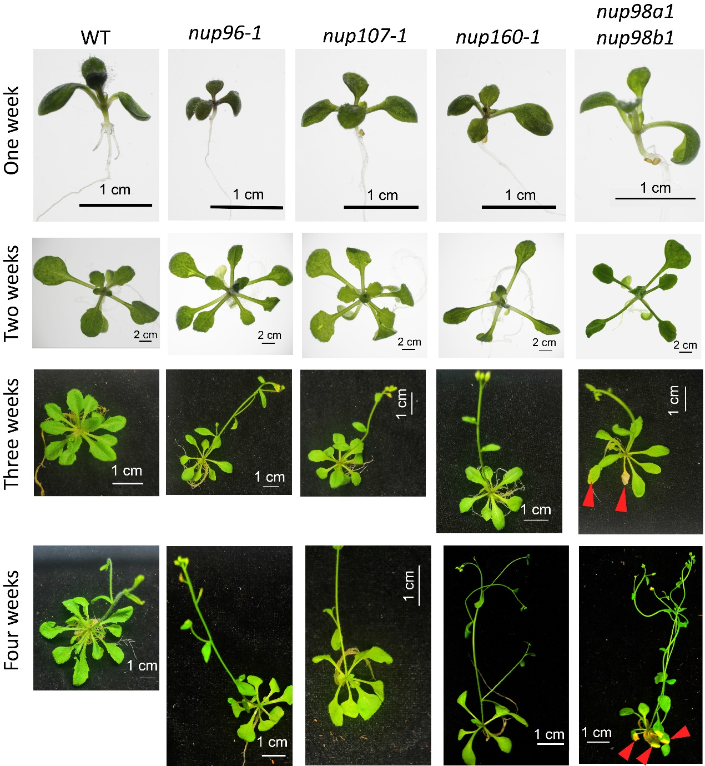
Figure S4. Senescence phenotypes were specific to the nup98a1 nup98b1 double mutant compared to mutants of other nucleoporins. The data showed that the mutants of nucleoporin genes, Nup96, Nup107, and Nup160, did not exhibit senescence characteristics even though plants were in bloom, while the nup98a1 nup98b1 mutant appeared senescence symptom (yellow leaves, red arrows) from three weeks after germination. All plants grew in long day conditions.

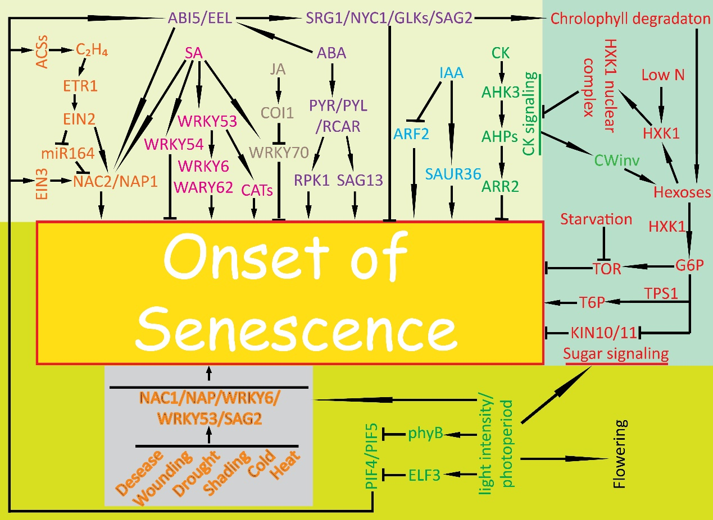
Figure S5. Molecular network of senescence initiation in plants. The summary is based on previous publications ¹⁻¹², but not limited these publications. Generally, initiation of senescence includes the hormone (light yellow background), sugar metabolism (light green background), and light and photoperiod pathway (green-yellow background), and stress pathways (grey background). These pathways can induce senescence at different developmental stages (yellow background). Genes and metabolites in the same pathway are indicated by the same color. Due to space limitations, this summary model does not include all genes identified to date. Abbreviations: ABA, abscisic acid; ABI, ABA INSENSITIVE; AHK, ARABIDOPSIS HISTIDINE KINASE; ACS, AMINOCYCLOPROPANE-1-CARBOXYLATE (ACC) SYNTHASE; AHP, ARABIDOPSIS THALIANA HISTIDINE PHOSPHOTRANSFER PROTEINS; ARF, AUXIN RESPONSE FACTOR; ARR, ARABIDOPSIS RESPONSE REGULATOR; C₂H₄, ethylene ; CAT, CATALASE; CK, cytokinin; COI1, CORONATINE INSENSITIVE 1; CWINV, CELL WALL INVERTASE; EEL, ENHANCED EM LEVEL; EIN, ETHYLENE INSENSITIVE; ELF, EARLY FLOWERING; ETR, ETHYLENE RESPONSIVE; G6P，6-phosphoric acid glucose; GLK, Golden 2-like Transcription factor; HXK1, HEXOKINASE 1; KIN, PROTEIN KINASE10; N, nitrogen; NAC，NAM, ATAF, AND CUC; NAP, NAC-LIKE PROTEIN; NYC, NONYELLOW COLORING; ORE, ORESARA; PHYB, phytochrome B; PIF, PHYTOCHROME INTERACTING FACTOR; PYR/PYL/RCAR, PYRABACTIN RESISTANCE/PYR1-LIKE ORREGULATORY COMPONENT OF ABA RECEPTOR; SAG, SENESCENCE-ASSOCIATED GENE; SAUR, SMALL AUXIN UPREGULATED; SGR, STAYGREEN; T6P, TREHALOSE-6-PHOSPHATE; TOR, TARGET OF RAPAMYCIN; TPS1, TREHALOSE-6-PHOSPHATE SYNTHASE 1; WRKY, WRKY DNA-BINDING PROTEIN. Arrowheads indicate promoting effect while short bars indicate inhibiting effect on senescence.

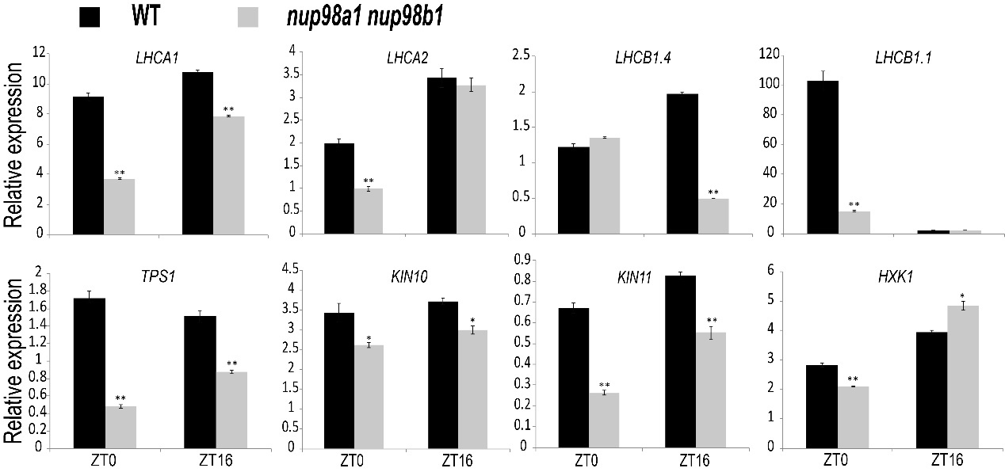
Figure S6. The expression of genes related to photosynthesis and sugar metabolism are altered in the nup98a1 nup98b1 double mutant. The nup98a1 nup98b1 double mutant and WT plants were grown in petri dishes in long day conditions for 14 days, and then harvested at ZT0 and ZT16 for gene expression analysis. All qPCR measurements were repeated at least three times, in triplicate. Gene expression measurements were normalized to the control At4g34270 and expressed as a relative expression value. Student’s t test was used to statistically analyze the data. An * indicates measurements that were significantly (*P < 0.05; **P <0.01) different from the control. Error bars indicate ± SD of the mean.

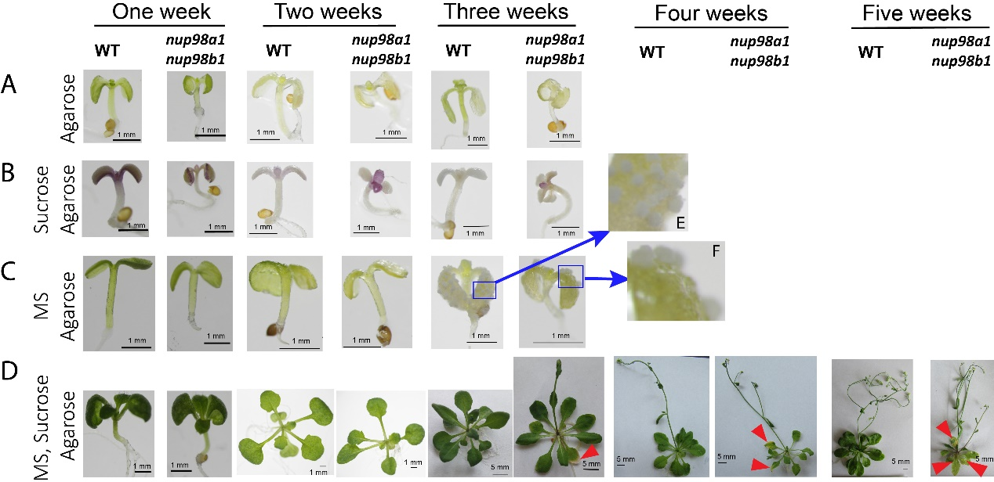
Figure S7. Time course analysis of the nup98a1 nup98b1 double mutant compared to WT grown on different mediums. Row A, agarose medium. Row B, agarose plus sucrose. Row C, agarose plus MS nutrients. Row D, agarose plus sucrose and MS nutrients. Plants cannot fulfil the life cycle and die in about three weeks after germination in medium A, B, and C, whereas plants in medium D can go through the life cycle. There were white callus-like structures found on the leaf surfaces of three week-seedlings on medium C (blue arrow, E and F). The nup98a1 nup98b1 double mutant displayed senescence leaves (red arrow heads) early than WT (from week three) as Figure 5 showed. We also observed that the seedlings of 25% of WT or 8% of the nup98a1 nup98b1 double mutant on medium C can grow normal more or less until three weeks after germination. All experiments were repeated at least twice, and one representative photo each was showed here.

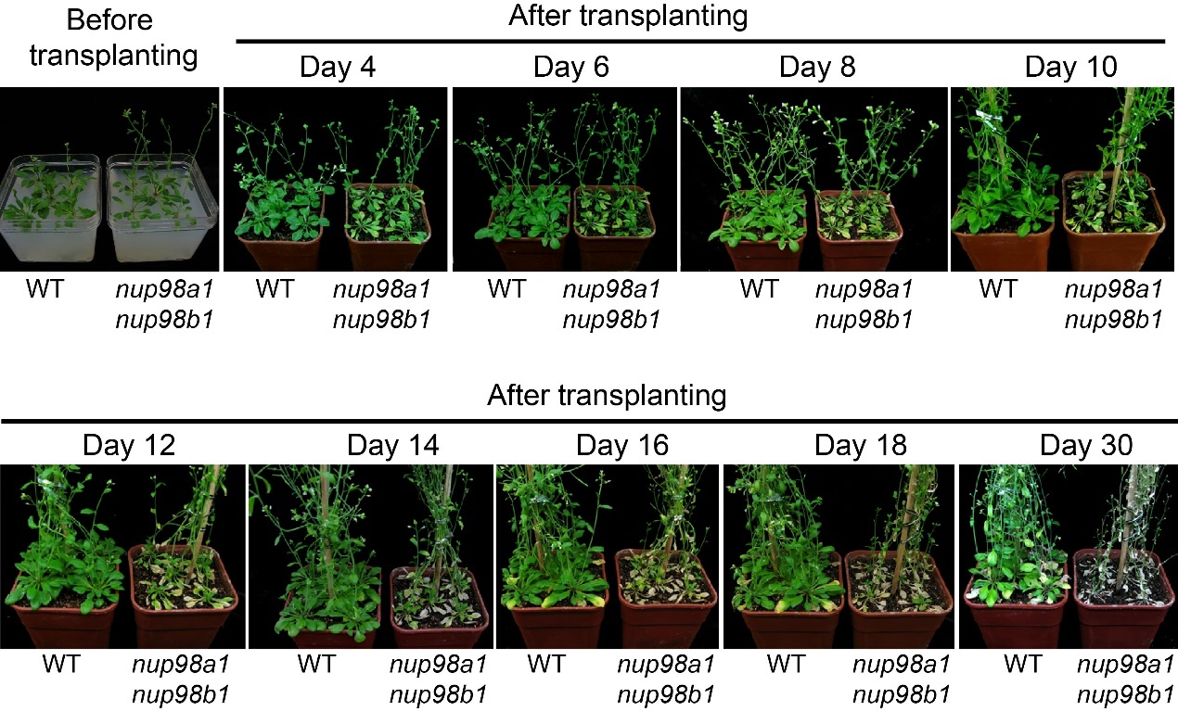
Figure S8. Exogenous sucrose reduces early onset senescence in the nup98a1 nup98b1 double mutant plants. The seeds of WT and the nup98a1 nup98b1 double mutant were sown on MS medium with sucrose. After stratification, plants were grown under long day conditions. After inflorescences emerged, plants were transplanted to soil. Senescence symptoms appeared 4 days later in the double mutant leaves, about 12 days earlier than the wild type control.

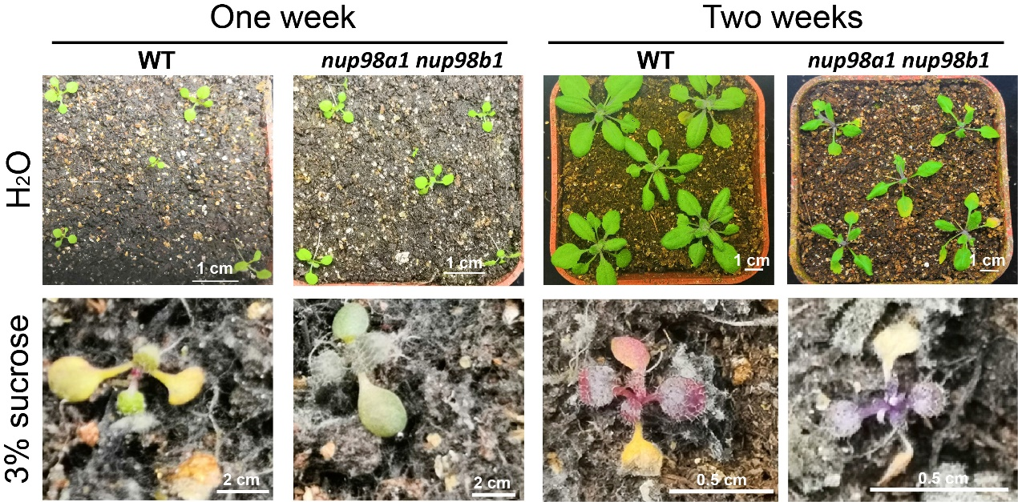
Figure S9 Sucrose enhanced pathogens growing, that polluted and killed seedlings. Seeds germinated on MS medium and five-day seedlings were transferred into soil in long day conditions, then watered with water (H₂O, upper row) or 3% sucrose (lower row). Photos were taken after one or two weeks. Scale bars were indicated on photos.

Supplementary Table 1. Primers used in this study.
Primer Name | Gene ID | Nucleotide Sequence (5’-3’) | Purpose
At4g34270-F | At4g34270  Reference gene | gtgaaaactgttggagagaagcaa | qRT-PCR
At4g34270-R | At4g34270  Reference gene | tcaactggataccctttcgca | qRT-PCR
AGL15-F | AT5G13790 | ttccttctaccttcttctc | qRT-PCR
AGL15-R | AT5G13790 | agtgacttgtctgctatt | qRT-PCR
AMY1-F | At4g25000 | cttggctatgattgatgat | qRT-PCR
AMY1-R | At4g25000 | ttatgcgttacttcttctc | qRT-PCR
AMY2-F | At1g76130 | ctcggttggagaatgttg | qRT-PCR
AMY2-R | At1g76130 | ctgattatacgctgtctatgg | qRT-PCR
AMY3-F | At1g69830 | tgagatattatgccaaggt | qRT-PCR
AMY3-R | At1g69830 | gaacagtgaatccaagtg | qRT-PCR
ARF2-F | At5g62000 | gatgatgataaggttgac | qRT-PCR
ARF2-R | At5g62000 | aatctgtgtaagtaggtt | qRT-PCR
ARP4-F | AT1G18450 | gtctgagtatgaggaaca | qRT-PCR
ARP4-R | AT1G18450 | ctaataatcttcaaggaacaac | qRT-PCR
BAM1-F | At3g23920 | accattgaagaacagagaa | qRT-PCR
BAM1-R | At3g23920 | tcatcacaaacacaggaa | qRT-PCR
BAM2-F | At4g00490 | agattcaggttgttatgt | qRT-PCR
BAM2-R | At4g00490 | aagtagatgtcaggattg | qRT-PCR
BAM3-F | At4g17090 | ggaatagcgagtatggaa | qRT-PCR
BAM3-R | At4g17090 | ctgaagataggagttggt | qRT-PCR
BAM4-F | At5g55700 | tgatgatgccgattgatac | qRT-PCR
BAM4-R | At5g55700 | gctaacttgagtgccttaa | qRT-PCR
BAM5-F | At4g15210 | aagataccgacaatacag | qRT-PCR
BAM5-R | At4g15210 | gcaacttctataccttct | qRT-PCR
BAM6-F | At2g32290 | gtcatcacgaacgataacg | qRT-PCR
BAM6-R | At2g32290 | accatcactccatctacttg | qRT-PCR
BAM7-F | At2g45880 | tggatgtgaaggaagaag | qRT-PCR
BAM7-R | At2g45880 | actcgtcattactactactg | qRT-PCR
BAM8-F | At5g45300 | cagagatggttgtatgagat | qRT-PCR
BAM8-R | At5g45300 | aggagaaggttgacgata | qRT-PCR
BAM9-F | At5g18670 | cttccgttagacacagtt | qRT-PCR
BAM9-R | At5g18670 | ctcaataccttctacaccaa | qRT-PCR
CAT1 | At1g20630 | tattcttcgtccgtgatg | qRT-PCR
CAT1 | At1g20630 | cagtatcctccagttctc | qRT-PCR
COI1-F | AT2G39940 | atggcggtgtatgtctcag | qRT-PCR
COI1-R | AT2G39940 | gcggaagtcacagaggtt | qRT-PCR
DPE1-F | At5g64860 | gcaaggagttgatataatgg | qRT-PCR
DPE1-R | At5g64860 | cgctaacaagaagaggaa | qRT-PCR
DPE2-F | At2g40840 | ggacttagactcaactatg | qRT-PCR
DPE2-R | At2g40840 | gattaccaccagattcaa | qRT-PCR
EBP1 | At3g51800 | ccaatcgctcctccttaa | qRT-PCR
EBP1 | At3g51800 | gaactcatctctgataactctc | qRT-PCR
GWD1/SEX1-F | At1g10760 | aagttggcaggttattagt | qRT-PCR
GWD1/SEX1-R | At1g10760 | ttgtaggtctatcgtaggt | qRT-PCR
GWD2-F | At4g24450 | agtgtgataatggatgaag | qRT-PCR
GWD2-R | At4g24450 | caatcgctgagaatagac | qRT-PCR
GWD3/PWD-F | At5g26570 | gacacatcaggagaatcaa | qRT-PCR
GWD3/PWD-R | At5g26570 | cagtatcaggagcatcatt | qRT-PCR
HXK1-F | AT4G29130 | ctacagaatgcgaagact | qRT-PCR
HXK1-R | AT4G29130 | taccagaggacagagaag | qRT-PCR
ISA3-F | At4g09020 | tggcatagacaacaaggt | qRT-PCR
ISA3-R | At4g09020 | tggatggttacagttcagt | qRT-PCR
KIN10-F | At3g01090 | cagatggtatgctcagtaac | qRT-PCR
KIN10-R | At3g01090 | tgcttcgttctctattatgc | qRT-PCR
KIN11-F | At3g29160 | gtttactttgccgggttac | qRT-PCR
KIN11-R | At3g29160 | ccatcaaaaagaagaaagga | qRT-PCR
LDA-F | At5g04360 | aatgatgagactgttgag | qRT-PCR
LDA-R | At5g04360 | aatgttggaagaagatgta | qRT-PCR
LHCA1-F | At3g54890 | tctcttcttccaagtctaa | qRT-PCR
LHCA1-R | At3g54890 | attctgatacgaccaaca | qRT-PCR
LHCA2-F | At3g61470 | aataatggcatcatctctt | qRT-PCR
LHCA2-R | At3g61470 | cagtcaacttcttcttca | qRT-PCR
LHCB1.1-F | At1g29920 | tgagccaagttctatctgt | qRT-PCR
LHCB1.1-R | At1g29920 | ctctaccatccaccacaa | qRT-PCR
LHCB1.4-F | At2g34430 | gagtgaagttcggagaag | qRT-PCR
LHCB1.4-R | At2g34430 | ccaagtagtccaatcctc | qRT-PCR
LSF1-F | At3g01510 | ggcattcagcaacttcac | qRT-PCR
LSF1-R | At3g01510 | agcaacatcaccaactaca | qRT-PCR
LSF2-F | At3g10940 | gagaacgatgagtgtgatt | qRT-PCR
LSF2-R | At3g10940 | agaagtgaagcaagaagatt | qRT-PCR
NAC1-F | AT1G56010 | aggagttatatgtagagac | qRT-PCR
NAC1-R | AT1G56010 | tgatgatgtagtgatgat | qRT-PCR
NAP-F | AT1G69490 | gaagaagagataatgatgatg | qRT-PCR
NAP-R | AT1G69490 | caggttgatgaagatgat | qRT-PCR
NPR1-F | AT1G64280 | attgccaaggattacgaagt | qRT-PCR
NPR1-R | AT1G64280 | tctcactctgctgctgta | qRT-PCR
ORE1/NAC2-F | At5g39610 | tacgaggcatcaagaatc | qRT-PCR
ORE1/NAC2-R | At5g39610 | aggtagtgagttatgagttc | qRT-PCR
PHS1-F | At3g29320 | ggattggtggagaagacat | qRT-PCR
PHS1-R | At3g29320 | gagccgcagattgatagt | qRT-PCR
PHS2-F | At3g46970 | agagattgacaagaggtt | qRT-PCR
PHS2-R | At3g46970 | acacataagttagccattc | qRT-PCR
RPS6A | At4g31700 | agaagccaagaatgagag | qRT-PCR
RPS6A | At4g31700 | ggtaagtgttgacataggt | qRT-PCR
SAG12-F | AT5G45890 | caagcactgatgaaggcagt | qRT-PCR
SAG12-R | AT5G45890 | tgcactctccagtgaacaca | qRT-PCR
SAG13 | AT2G29350 | gacaacataaggacgaactctg | qRT-PCR
SAG13 | AT2G29350 | tacgcaccgcttctttct | qRT-PCR
SAG2-F | AT5G60360 | tcttcttcttcttcttcttct | qRT-PCR
SAG2-R | AT5G60360 | aactactgatgataggattgt | qRT-PCR
SAUR36 | AT2g45210 | atgtctcgtctcactctc | qRT-PCR
SAUR36 | AT2g45210 | atcttcctcatcttcttatagc | qRT-PCR
SEN1-F | At4g35770 | gcttggacagagaatgag | qRT-PCR
SEN1-R | At4g35770 | tgattgatacttgcgttga | qRT-PCR
SEX4-F | At3g52180 | tcttcttcttcttcttct | qRT-PCR
SEX4-R | At3g52180 | gtcttggctatattcatc | qRT-PCR
TPS1-F | AT1G78580 | catcaggagaccgaagac | qRT-PCR
TPS1-R | AT1G78580 | tgttgttgttgttagagttagag | qRT-PCR
WRKY53-F | At4g23810 | catcatcgccaagattacat | qRT-PCR
WRKY53-R | At4g23810 | ggtccttctaagcctctc | qRT-PCR
WRKY6-F | At1g62300 | ttctccttcgttaatctc | qRT-PCR
WRKY6-R | At1g62300 | atcatcttcttcgtcaat | qRT-PCR
WRKY70-F | At3g56400 | aatgaaggaagaagacaa | qRT-PCR
WRKY70-R | At3g56400 | gcctgatgatgataatct | qRT-PCR
RT98a-F | At1g10390 | atccgttgtcaaactacagagg | RT-PCR
RT98a-R | At1g10390 | ggagacgagccaaaactaaagg | RT-PCR
RT98b-F | At1g59660 | ccaactcctgttacaaacccat | RT-PCR
RT98b-R | At1g59660 | gtccaatctctcgccttccatc | RT-PCR
DRM1-qRT-F | At1g28330 | AGGAAGGAACATGTGGCACT | qRT-PCR
DRM1-qRT-R | At1g28330 | GAGTCACCGCTGTACAACCA | qRT-PCR
DIN6-qRT-F | AT3G47340 | TCTCGACCCTGAATCCAAGATGAT | qRT-PCR
DIN6-qRT-R | AT3G47340 | GTCGTCAAAGGCTCTCCTTAGA | qRT-PCR
ATG8a-qRT-F | AT4G21980 | CAATTTGTATACGTGGTTCGT | qRT-PCR
ATG8a-qRT-R | AT4G21980 | AGCAACGGTAAGAGATCCAA | qRT-PCR
ATG8E-qRT-F | AT2G45170 | TCTTTAAGATGGACAACGATTTC | qRT-PCR
ATG8E-qRT-R | AT2G45170 | CTCAGCCTTTTCCACAATCA | qRT-PCR
SAG12-qRT-F1 | At5g45890 | TATTACAGGTTATGAGGATGTCCC | qRT-PCR
SAG12-qRT-R1 | At5g45890 | ACCACATAGTCCTTGTTTATCC | qRT-PCR
WRKY53-qRT-F1 | AT4G23810 | CTTCTGCTAAACTGGTCATCC | qRT-PCR
WRKY53-qRT-R1 | AT4G23810 | CTCTCTCTGGGCTTATTCTCA | qRT-PCR
ACT2-F | At5g09810 | CTCATGAAGATTCTCACTGAG | RT-PCR
ACT2-R | At5g09810 | ACAACAGATAGTTCAATTCCCA | RT-PCR
TIP41-F | At4g34270 | GTGAAAACTGTTGGAGAGAAGCAA | qRT-PCR
TIP41-R | At4g34270 | TCAACTGGATACCCTTTCGCA | qRT-PCR

Reference:
1 Lim, P. O., Kim, H. J. & Nam, H. G. Leaf senescence. Annu Rev Plant Biol 58, 115-136, doi:10.1146/annurev.arplant.57.032905.105316 (2007).
2 Khan, M., Rozhon, W. & Poppenberger, B. The role of hormones in the aging of plants - a mini-review. Gerontology 60, 49-55, doi:10.1159/000354334 (2014).
3 Guo, Y. Towards systems biological understanding of leaf senescence. Plant Mol Biol 82, 519-528, doi:10.1007/s11103-012-9974-2 (2013).
4 Guiboileau, A., Sormani, R., Meyer, C. & Masclaux-Daubresse, C. Senescence and death of plant organs: nutrient recycling and developmental regulation. C R Biol 333, 382-391, doi:10.1016/j.crvi.2010.01.016 (2010).
5 Zhang, H. & Zhou, C. Signal transduction in leaf senescence. Plant Mol Biol 82, 539-545, doi:10.1007/s11103-012-9980-4 (2013).
6 Thomas, H. Senescence, ageing and death of the whole plant. New Phytol 197, 696-711, doi:10.1111/nph.12047 (2013).
7 Jibran, R., Hunter, D. A. & Dijkwel, P. P. Hormonal regulation of leaf senescence through integration of developmental and stress signals. Plant Mol Biol 82, 547-561 (2013).
8 Bakshi, M. & Oelmuller, R. WRKY transcription factors: Jack of many trades in plants. Plant signaling & behavior 9, e27700 (2014).
9 Sheen, J. Master Regulators in Plant Glucose Signaling Networks. 57, 67-79, doi:10.1007/s12374-014-0902-7 (2014).
10 Koyama, T. The roles of ethylene and transcription factors in the regulation of onset of leaf senescence. Frontiers in plant science 5, 650, doi:10.3389/fpls.2014.00650 (2014).
11 Hinderhofer, K. & Zentgraf, U. Identification of a transcription factor specifically expressed at the onset of leaf senescence. Planta 213, 469-473 (2001).
12 Miao, Y., Laun, T., Zimmermann, P. & Zentgraf, U. Targets of the WRKY53 transcription factor and its role during leaf senescence in Arabidopsis. Plant Mol Biol 55, 853-867, doi:10.1007/s11103-004-2142-6 (2004).

